AskAdria.com

Learn what your options are instead of shelling out $200+ for Microsoft’s productivity software. Someone asked me the other day where they could “download” Microsoft Office.
I looked in my Gmail and saw that this friend had asked me 3 times in 4 years about getting Microsoft Office and I knew it was time to do a show!
- Cost - Open Office and Google Docs
- Basic functionality – Tie
- Advanced functionality – Microsoft Office and Open Office
- Look of the application – Microsoft Office
- Support from developers – Open Office
- Sharing files with others – Google Docs
- Offline access – Tie
- Formatting, print preview – Microsoft Office
- Revision control – Google Docs
- Installation - Google Docs
- Updates - Google Docs
- PDF creation – Open Office and Google Docs
- USB flash drive, portable version – Open Office and Google Docs (via FoxGLove)
- Compatibility for file extensions – Open Office and Google Docs
- Compatibility across operation systems, Windows, Mac Linux – Open Office and Google Docs

Summary
Most people have basic wordprocessing and spreadsheet needs. Creating resumes and sending letters…managing lists of people or simple financials is the extent of of most people do inside of a productivity suite.

Many people are used to using Microsoft Office. It will go the way of Lotus 123, Star Office and the dinosaur. People are spending hundreds of dollars on a software program because it’s “what they know”. I ask to you explore your options because it’s easier than you think.

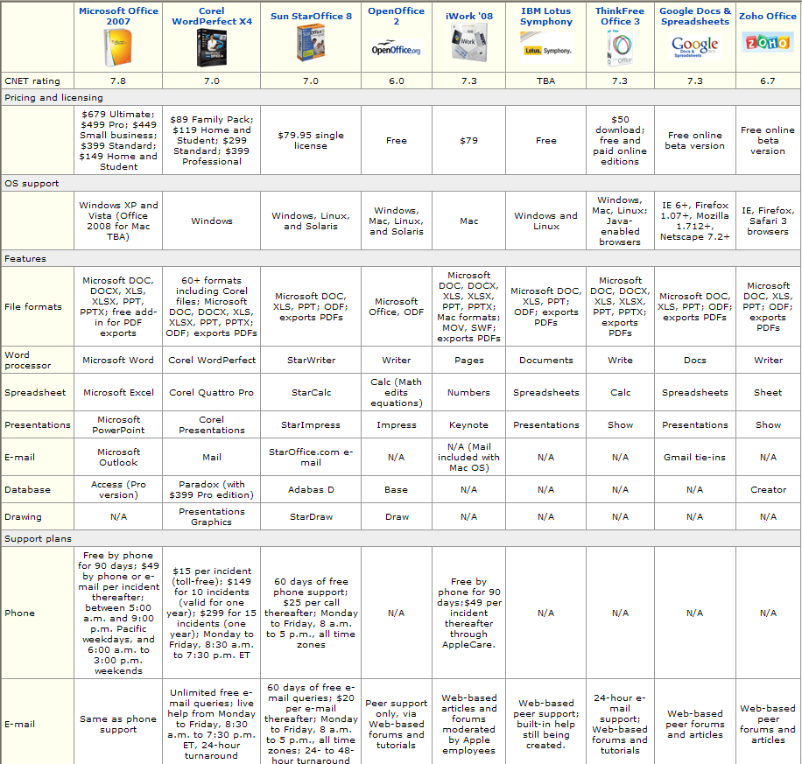

With Windows 7 in the bag, Microsoft is now preparing us for its next big launch, with Office 2010 due for release in June 2010. Today saw the announcement of the various SKUs and pricing details for each. Prices have generally been lowered, with more choice being given to consumers. This is clearly an attempt to better battle the onslaught from free alternatives such as Google Apps and OpenOffice.
Microsoft Office is immensely popular, and has been for as long as I can remember. The suite of applications such as Word, Excel, and PowerPoint have been with us for over 20 years now, with the first iteration of the software making its debut on the Macintosh in 1989. And now we’re just six months away from Office 2010 landing in stores, although the beta is already ongoing.
The line-up and details for Office 2010, as detailed by ZDNet, are as follows:
Office 2010 Starter
A free, OEM-only SKU designed to replace Microsoft Works. Contains Word and Excel only, and will be ad-supported.
Office 2010 Professional Academic
Designed to be bought and used by students and educators, this SKU will be sold on university campuses for $99, making it the cheapest version of Office 2010 being made available. Contains Word 2010, Excel 2010, PowerPoint 2010, OneNote 2010, Outlook 2010, Publisher 2010, Access 2010, and Office Web Apps.
Office 2010 Home and Student
Can be installed and run on three PCs in one house in a similar way to the Windows 7 Family Pack. Contains Word 2010, Excel 2010, PowerPoint 2010, OneNote 2010, and Office Web Apps. Priced at $149 for the boxed version and $119 for the product key card.
Office 2010 Home and Business
Designed for small businesses. Contains Word 2010, Excel 2010, PowerPoint 2010, OneNote 2010, Outlook 2010, and Office Web Apps. Priced at $279 boxed and $199 for a product key card.
Office 2010 Professional
The daddy of them all, and priced accordingly. For the $499 (boxed) and $349 (product key card) asking prices, you’ll get Word 2010, Excel 2010, PowerPoint 2010, OneNote 2010, Outlook 2010, PUblisher 2010, Access 2010, Office Web Apps, and premium technical support.
There are also set to be office 2010 Professional Plus and Office 2010 Standard SKUs but details are still thin on the ground.
The increased options and lower price points are genuinely good innovations for this latest version of Microsoft Office. However, whether they’ll be enough to overcome the increasing popularity of Google Apps and OpenOffice remains to be seen. They are, after all, both free to use. And even the lowest price point cannot hope to compete with free.

Google will trounce Microsoft in a showdown on multiple fronts — As the search giant’s ambitions continue to grow, it’s not just threatening the startups in its path, but also king of the hill Microsoft. Next year expect to see Google challenge Microsoft’s flagships, Windows and Office.
In 2009, Google finally took the beta testing label of online applications like Gmail, Google Docs, and Google Calendar; it launched a rare advertising campaign called “Gone Google” for those products; and company executives are boasting that 2010 will be the year that Google Apps (the business bundle that includes Gmail, Google Docs, and more) becomes a viable alternative to Office. That doesn’t mean Docs will be a perfect match for Word, but the service will improve enough that Microsoft’s price tag will start to seem mighty onerous. And early versions of an online version of Office are still rough.
Meanwhile, Google’s new netbook operating system, Chrome OS, should be available to consumers by the holiday season, and while it won’t replace Windows anytime soon, you can expect it to make a big splash. And anticipation is building around this week’s rumored launch of the Nexus One, a phone using Google’s Android operating system that the company designed itself, which will probably leave Windows Mobile even further in the dust. (Anthony Ha)
Bangalore: Don Dodge, a Google employee and former executive of Microsoft says that Microsoft is no longer fast or innovative and is now what IBM was in 1985. He further says that Microsoft is now passed by other companies like Apple, Facebook and Google. But he still feels that Microsoft has an advantage in some areas, particularly development and software, but it now has major competitors in most areas and in some cases has been eclipsed, according to Electronista.
"Very few companies can dominate an industry for more than 20 years," Dodge explains to the Seattle Post-Intelligencer. "It is just the natural competitive cycle." He adds that having the company founders active and in charge is important to the company dynamic and that Microsoft has lost this with Paul Allen and more recently Bill Gates having left their daily roles. Google is helped by Larry Page and Sergey Brin still working at the company, while Steve Jobs continues to helm Apple.
Dodge says that Microsoft has had its own share of failures in the form of Windows Mobile and Windows Vista. Windows Mobile has not been able to be a tough competition for Apple's iPhone and Google's Android.
Dodge predicts that Microsoft will face trouble in other areas and in 2010 is likely to lose many traditional Office customers to web-based Google technologies like Gmail and Google Apps as they decide to use the cheaper, more frequently updated web tools in place of costly offline software.
Resources: http://excel.tips.net/ http://word.tips.net/ http://support.openoffice.org ,http://edu.googleapps.com/tutorials-and-tips

